**Problem 1:**

#include<stdio.h>

main()

{

int i,j,k=5;

for (i=1;i<=5;i++)

{

for (j=1;j<=i;j++)

{

printf("%d ",k);

k++;

}

printf("\n");

}

}

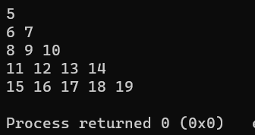

**Problem 2:**

#include<stdio.h>

main()

{

int i,j;

for (i=1;i<=5;i++)

{

for (j=1;j<=i;j++)

{

printf("* ");

}

printf("\n");

}

}

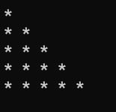

**Problem 3:**

#include<stdio.h>

main()

{

int i,j;

for (i=5;i>=1;i--)

{

for (j=1;j<=i;j++)

{

if

(i==5||j==1||j==i)

printf("*");

else

printf(" ");

}

printf("\n");

}

}

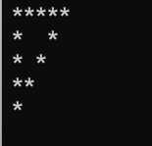

**Problem 4:**

#include<stdio.h>

main()

{

int i,j;

for (i=5;i>=1;i--)

{

for (j=1;j<=i;j++)

{

printf("%d ",i);

}

printf("\n");

}

}

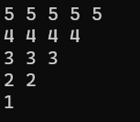

**Problem 5:**

#include<stdio.h>

main()

{

int i,j;

for (i=1;i<=5;i++)

{

for (j=1;j<=i;j++)

{

printf("%d ",j);

}

printf("\n");

}

}

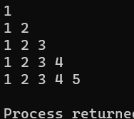

**Problem 6:**

#include<stdio.h>

main()

{

int i,j;

for (i=1;i<=4;i++)

{

for (j=1;j<=8;j++)

{ if

(i==1||i==4||j==1||j==8||j==4)

printf("* ");

else

printf(" ");

}

printf("\n");

}

return 0;

}

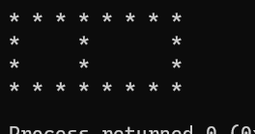

**Problem 7:**

#include<stdio.h>

main()

{

int i,j,k;

for (i=1;i<=5;i++)

{

for (j=1;j<=5-i;j++)

{

printf(" ");

}

for (k=1;k<=i;k++)

{

printf("* ");

}

printf("\n");

}

return 0;

}

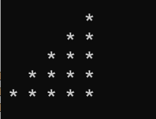

**Problem 8:**

#include<stdio.h>

main()

{

int i,j,k;

for (i=1;i<=5;i++)

{

for (j=1;j<=5-i;j++)

{

printf(" ");

}

for (k=1;k<=i;k++)

{

printf(" * ");

}

printf(" \n");

}

return 0;

}



**Problem 9:**

#include<stdio.h>

main() {

int i,j,k;

for (i=1;i<=5;i++)

{

for (j=1;j<=5-i;j++)

{

printf(" ");

}

for (k=1;k<=2*i-1;k++)

{

if (i==1||k==1||i==5||k==2*i-1||k==i)

printf("*");

else

printf(" ");

}

printf("\n");

}

return 0;

}

